MATLAB PEX 3 REPORT

Bradley Trowbridge

Programming Languages

Dean Bushey

Number of Pits: 152

Number of Peaks: 533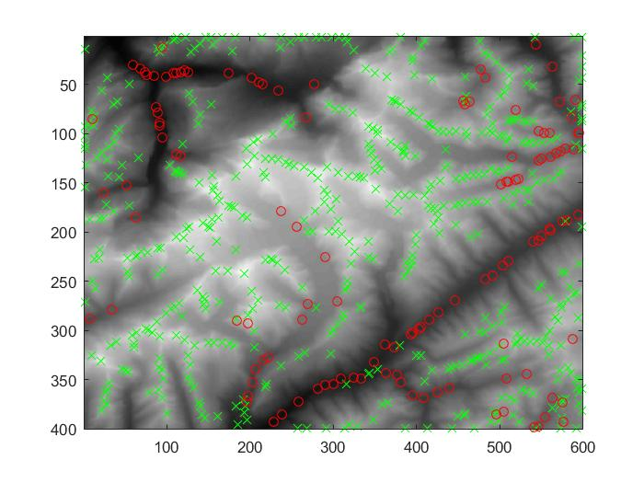

plotRaindrop:

